

­­­

OOP Lab-06 Tasks

Name: Syed Muhammad Raza Ali

Enrolment: 02-134231-028

Course: OOP Lab

Faculty: Miss Hafsa Munawar

Designing and implementing Java programs that deal with:

1. **Association and**
2. **Aggregation**

Exercises

Exercise 1(a)

Create a jav program based on the guivrn UML diagram and implement the relation between the classes as shown in the diagram

Exercise 1(b)

Create Driver class named as **Association_aggregation_1**. Create proper Objects of all classes as follows

* 2 Objects of Course class
* 3 Objects of Faculty class
* 3 Objects of Departement Class

And properly display all the information

package com.mycompany.mavenproject2;

import java.util.ArrayList;

class Course{

private String courseCode,courseName,courseCreditHours;

//constructor

Course(String courseCode,String courseName, String courseCreditHours){

this.courseCode = courseCode;

this.courseName = courseName;

this.courseCreditHours = courseCreditHours;

}

//methods

public String getCourseCode(){

return courseCode;

}

public String getCourseName(){

return courseName;

}

public String getCourseCreditHours(){

return courseCreditHours;

}

}

class Faculty{

private String facultyName,facultyDesignation,facultyEmail,facultyContact;

private int facultySalary, facultyId;

private ArrayList<Course> courseList = new ArrayList<Course>();

//constructor

Faculty(String facultyName, String facultyDesignation, String facultyEmail, String facultyContact, int facultySalary, int facultyId){

this.facultyName = facultyName;

this.facultyDesignation = facultyDesignation;

this.facultyEmail = facultyEmail;

this.facultyContact = facultyContact;

this.facultySalary = facultySalary;

this.facultyId = facultyId;

}

//methods

public void assignCourse(Course course){

courseList.add(course);

}

public String getFacultyName(){

return facultyName;

}

public String getFacultyDesgination(){

return facultyDesignation;

}

public String getFacultyEmail(){

return facultyEmail;

}

public String getFacultyContact(){

return facultyContact;

}

public int getFacultySalary(){

return facultySalary;

}

public int getFacultyId(){

return facultyId;

}

public void printAll(){

System.out.println("Faculty Name : "+facultyName+"\n"+

"Faculty Designation : "+facultyDesignation + "\n"+

"Faculty Email : "+ facultyEmail+ "\n"+

"Faculty Contact : "+facultyContact+"\n"+

"Faculty Salary : "+facultySalary+"\n"+

"Faculty Id : "+facultyId+"\n=============== Faculty Courses =============== \n");

for(int i = 0;i<courseList.size();i++){

System.out.println( "* Course "+(i+1)+" : ");

System.out.println("Course code : "+courseList.get(i).getCourseCode());

System.out.println("CourseName : "+courseList.get(i).getCourseName());

System.out.println("CourseCreditHours : "+courseList.get(i).getCourseCreditHours());

}

}

}

class Department{

private String departmentName;

private ArrayList<Faculty> departmentFaculty = new ArrayList<Faculty>();

private ArrayList<Course> offeredCourses = new ArrayList<Course>();

//methods

Department(String departmentName){

this.departmentName = departmentName;

}

public void facultyList(Faculty faculty){ //assigning faculty

departmentFaculty.add(faculty);

}

public void courseList(Course course){

offeredCourses.add(course);

}

public void printAll(){

System.out.println("Department Name : "+departmentName);

System.out.println("============= Faculty List =============");

for (int i = 0; i <departmentFaculty.size() ; i++) {

System.out.println("* Faculty "+(i+1));

System.out.println("Faculty Name : "+departmentFaculty.get(i).getFacultyName()+"\n"+

"Faculty Designation : "+departmentFaculty.get(i).getFacultyDesgination()+ "\n"+

"Faculty Email : "+ departmentFaculty.get(i).getFacultyEmail()+ "\n"+

"Faculty Contact : "+departmentFaculty.get(i).getFacultyContact()+"\n"+

"Faculty Salary : "+departmentFaculty.get(i).getFacultySalary()+"\n"+

"Faculty Id : "+departmentFaculty.get(i).getFacultyId());

}

System.out.println("============= Course List =============");

for (int i = 0; i <offeredCourses.size() ; i++) {

System.out.println("* Course "+(i+1));

System.out.println("Course code : "+offeredCourses.get(i).getCourseCode());

System.out.println("CourseName : "+offeredCourses.get(i).getCourseName());

System.out.println("CourseCreditHours : "+offeredCourses.get(i).getCourseCreditHours());

}

}

}

public class Mavenproject2 {

public static void main(String[] args) {

//Two objects of course

Course c1 = new Course("0000","oop","12");

Course c2 = new Course("001","CP","18");

//Three objs of Faculty

Faculty f1 = new Faculty("Syed Raza","Lecturer","asyedraza85632@gmail.com","121212121",24000,1234);

Faculty f2 = new Faculty("Aimen","TA","aimen@gmail.com","232323232",10000,1248);

Faculty f3 = new Faculty("Muskan","Lecturer","muskan123@gmail.com","98989898",15000,1233);

//Three objs of Department

Department d1 = new Department("Computer Science");

Department d2 = new Department("IPP");

Department d3 = new Department("Maritime");

//Assigning faculty to depart

d1.facultyList(f1);

d1.facultyList(f2);

d1.facultyList(f3);

//Assigning Courses to depart

d1.courseList(c1);

d1.courseList(c2);

//assigning courses to faculty

f1.assignCourse(c1);

f1.assignCourse(c2);

f1.printAll();

//printing faculty and courses in a depart

d1.printAll();

}

}

Output:

Creating two course objects and assigning them to a faculty obj

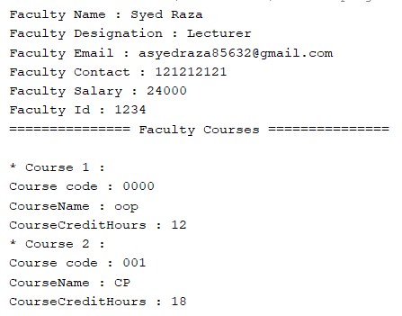

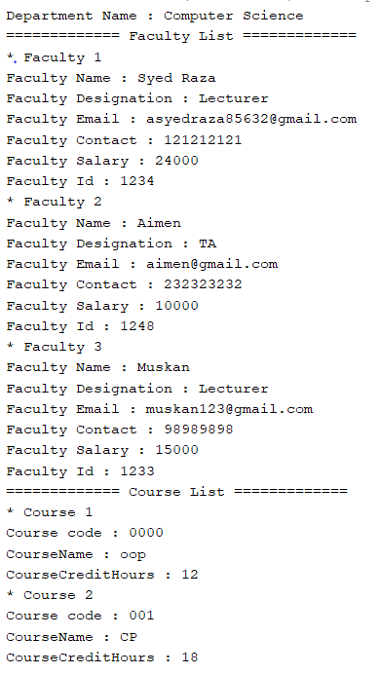Creating Two objects of courses and three objects of faculty and assigning them to an obj of department, then printing all the details